Name___________________ Test Your Knowledge!
Score: ____/10
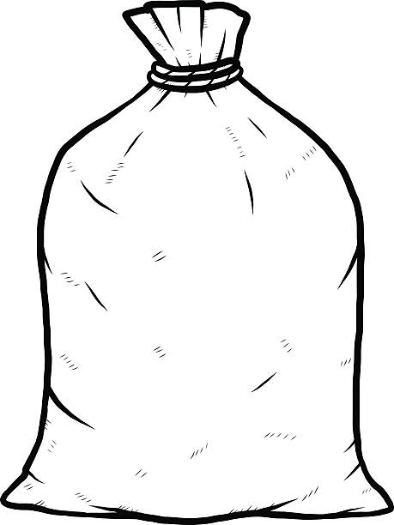
Circle the best answer(s).

1. What are microplastics? Circle all that apply.
a. Tiny pieces of plastic about the size of or smaller than sand grains.
b. Small bits of plastic often consumed by tiny organisms such as zooplankton.
c. Plastic babies found in king cakes.
d. Plastic fibers shed when synthetic clothing is laundered.
e. Tiny plastic beads used as abrasives in many personal care products.
f. Plastic pellets (nurdles) used as raw material to make plastic products.

2. In which of the following have microplastics been found? Circle all that apply.
a. Tissues of bivalves such as oysters and mussels
b. Stomachs of ocean fish
c. Sea salt
d. Halley’s Comet
e. Bottled water
f. Ocean water
g. Beaches

3. What are microplastic fibers?
a. Plastic fragments shed from synthetic clothes.
b. All man-made plastic that ends up in the ocean.
c. Tiny bits of plastic found in exfoliating body washes and scrubs.

4. Once in the marine environment, it is fairly easy to remove microfibers.
a. True b. False

5. Plastics often fragment into smaller pieces, ultimately becoming microplastics.
a. True b. False

6. Microplastics are small pieces of plastic ______ in size.
a. 10 mm or smaller
b. 7 mm or smaller
c. 5 mm or smaller
d. 1 mm or smaller

7. In 2018, what was the most common litter item collected in beach sweeps around the world?
a. plastic straws b. plastic bottles c. king cake babies d. cigarette butts e. plastic bags

8. Which of the following is biodegradable?
a. microfibers b. plastic bottles c. aluminum foil d. leather shoes e. nurdles f. microplastics

9. Plastic trash in the ocean mainly comes from
a. ships b. space c. airplanes dumping trash from the sky d. land

10. Why is plastic dangerous for marine life?
a. They mistake it for food and cannot digest it.
b. They can get tangled in it which hinders their ability to swim.
c. It is not dangerous because they use plastic waste for habitats.
d. both a and b
Test Your Knowledge!
ANSWERS:
1. a, b, d, e, f

2. a, b, c, e, f, g

3. a

4. b

5. a

6. c

7. d

8. d

9. d

10. d

