SEWAGE TREATMENT SYSTEM MAINTENANCE CLASS BEING OFFERED
CLASS IS FREE! MEAL/REFRESHMENTS PROVIDED
You are invited to attend a free class on sewage treatment system maintenance. The information is geared toward homeowners and owners/operators of on-site sewage treatment systems as part of an effort to protect Bayou Lafourche from receiving improperly treated sewage. The information provided will help you avoid unsanitary conditions from impacting your home or business.
Please try to attend one of the classes listed below. Classes are two hours in duration.
Date | Time | Location
December 10, 2018 | 6:00 pm to 8:00 pm | Lafourche Ph. Gov. Office, Mathews Complex Training Room, 4876 Hwy. 1, Mathews, La
December 11, 2018 | 12:00 pm to 2:00 pm | Freddie Falgout VFW Post 3665, 127 St. Philip St., Raceland, La
December 11, 2018 | 6:00 pm to 8:00 pm | Lockport Volunteer Fire Department, 606 Crescent Ave., Lockport, La

For more information contact Jesse Means, DEQ Geologist - (225) 219-1827, jesse.means@la.gov or Rusty Reeves, LRWA Deputy Director - (337) 738-2896, rustree@centurytel.net.
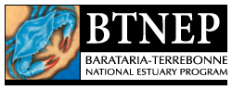
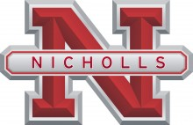
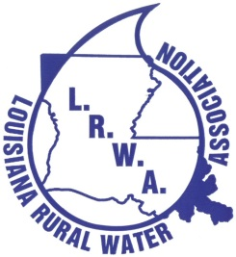
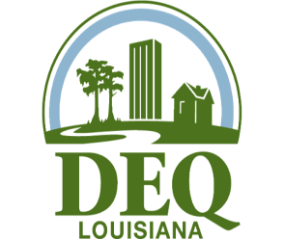
Present this flyer at the event to receive promotional items and to be eligible for a door prize.

