Position DESCRIPTION |  |  |  | 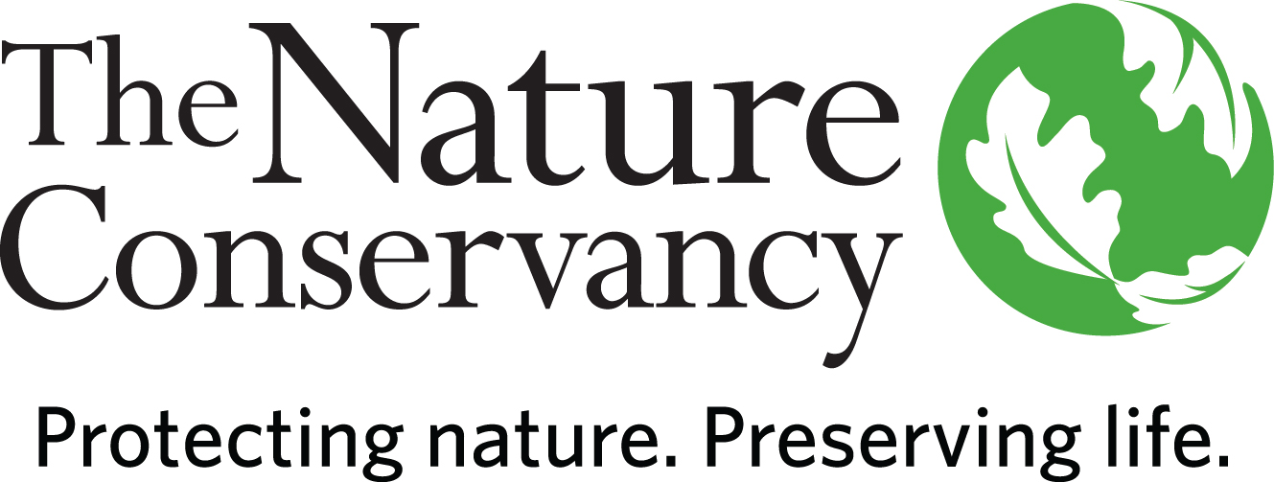
JOB TITLE | Human Resources Generalist I
JOB FAMILY | Human Resources
JOB NUMBER | 700006
SALARY GRADE | 6
STATUS | Salaried
DATE LOCATION | August 24, 2017  MS, TX, WO
ABOUT US | The Nature Conservancy is the leading conservation organization working to make a positive impact around the world in more than 69 countries, all 50 United States, and your backyard. Founded in 1951, the mission of The Nature Conservancy is to conserve the lands and waters on which all life depends. One of our core values is our commitment to diversity. Therefore, we are committed to a globally diverse and culturally competent workforce. Visit www.nature.org to learn more.
SUMMARY | The Human Resources Generalist I provide human resources services in one or more of the following functions: employee relations, compensation, talent management, benefits, payroll, staff development and training, organizational development and recruiting. This position supports the HR Business Partner (HRBP) with implementing HR initiatives to a variety of global business units. This position may be located in MS, TX, or WO.
ESSENTIAL  FUNCTIONS | The Human Resources Generalist I is responsible for administering and maintaining HR systems, programs, procedures and plans according to HR policies and will provide assistance to all levels of personnel on various HR-related issues. Job duties will vary; some tasks are routine and administrative while other responsibilities may be complex and high level. This position must be able to maintain confidentiality. Additionally, requires the ability to be an independent thinker. Must have excellent interpersonal skills with a commitment to deliver excellent customer service.
RESPONSIBILITIES & SCOPE | - Responds to routine employee/management questions and problems based on developing knowledge of aspects applicable to the subject area. Must be organized and a self-starter with the ability to work at a fast pace. Must be flexible and can adapt to frequent change in the Conservancy.
MINIMUM QUALIFICATIONS | - Bachelor’s degree or 3 years HR related work experience or equivalent combination.  - Experience responding to HR related questions and problems from employees/management.  - Experience in one or more of the following areas: database management and spreadsheet software; constructing and producing reports; data input, manipulation and analysis.  - Experience working with MS Office software, including Word, Excel, Access and PowerPoint.
PREFERRED KNOWLEDGE, SKILLS & EXPERIENCE | - Multi-lingual skills and multi-cultural or cross cultural experience appreciated.  - Solid knowledge of word processing, database management, and spreadsheet software, with ability to construct and produce reports, data input, manipulation, and analysis.  - Broad understanding of fundamental HR concepts, processes, and services.  - Strong organizational skills and attention to detail.  - Flexible work schedule. The Nature Conservancy is a Global Organization and this position may support several different time zones.  - May require fluency in foreign language(s) to support global operations.
ORGANIZATIONAL COMPETENCIES | Communications | Effectively expresses messages verbally and in writing. Actively listens to others. Fosters open exchange of issues. Is timely with information.
 | Flexibility & Innovation | Flexible to changing circumstances. Takes innovative approaches towards work. Takes calculated risks and makes dependable decisions in the face of uncertainty.
 | Interpersonal Savvy | Maintains positive working relationships. Contributes to productive partnerships inside and outside the organization. Understands team member roles and values the contributions of others. Effectively deals with conflict.
 | Open to Learning | Versatile learner and committed to self-improvement. Employs strengths effectively. Willingly shares knowledge with others. Seeks coaching on areas needing improvement. Adjusts behavior/performance as needed. Views mistakes as learning opportunities.
 | Organizational Awareness | Understands the basics of our business. Knows how local job relates to the big picture & contributes to the overall strategy. Knows how/why things work inside TNC. Easily moves through internal networks and channels for success.
 | Produces Results | Takes Initiative. Focuses on priorities. Strives for excellence. Is dependable and accountable for results. Persistent in the face of obstacles and meets deadlines.
This description is not designed to be a complete list of all duties and responsibilities required for this job.

